Scanning in DocFinity Version 10

Open Scanning Workspace on Workspace menu.

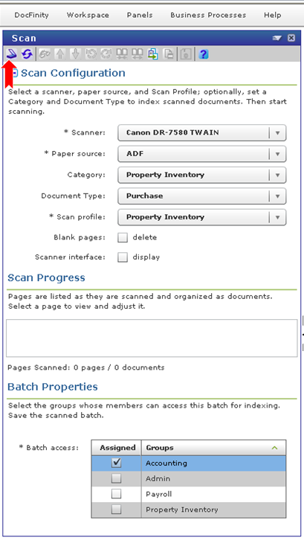

Scan Configuration section sets up scan for batches. User makes selections prior to scanning.
Scanner: Select Twain.
Paper Source: Select ADF = automatic document feeder. Flatbed is scan one page at a time process.
Category: Select your department name. (Accounting, Financial Reporting, Payroll, etc..)
Document Type: Will set the first metadata tag for the images. If all images are of one type (checks, vouchers, cash receipts, etc) select the document type to be tagged onto each image. For batch containing a mixture of types select Unindexed.
Scan Profile: Profile is set up by Administrator. It controls single page or mulit-page scanning, which scanner is to be used, etc. New Scan Profiles can be set up when needed. Contact DocFinity Support.
Blank pages: Selecting the delete checkbox will turn on the function that will delete blank pages during the scanning process. Turn on when: 2-sided and 1-sided documents are contained within the set of pages to be scanned.
Scanner interface: Selecting this checkbox will open the Scanner Properties window. User may select new scanning settings. These selections will override the Scanner Profile. This option is good for an occasional change. Request a new scanning profile with specific settings if needed.

Additional Option: Barcode Separator Page placed between documents will allow single page and multi page documents to be included in same batch. Bar Code Separator page is printed and inserted between documents prior to scan. Bar code separator pages can be reused. It may be more efficient to group single page documents into a batch and the multiple page documents into a batch. On Menu bar click Print Barcode icon to print barcode page.
Scan Progress: This section displays images as they are scanned allowing for quick quality check and manipulation of images. Use Button Bar or Panel Menu commands to edit, delete, rotate, reorder, combine images, split images, and more.
Batch Properties: Access to the Batch has to be assigned prior to scanning. Select each group of users who will need access to the batch for indexing.

Start Scan

- Click the Scan button on the button bar.
- Scanned documents will be added to a folder in the Scan Progress window named with the Document Type selected for the document.
- Number of pages in the scan will display to the right of the folder name. See screen shot below.

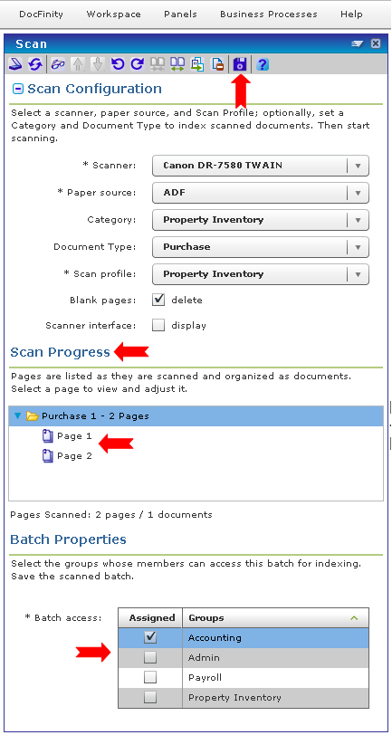

Check Image Quality

- Click the arrow to the left of the folder to display individual pages by number.
- Click on a page to display it in the Document Viewer.
- Pages can be edited or deleted using the Button Bar in the Scan Panel or the Document Viewer.
Save Scan

- Each scan must be saved to create a Batch.
- Select scan folder and click Save button on Button Bar.
- Batch is automatically named by system. Batch naming convention is set up by administrators.
- Unsaved scans will be deleted when user logs out of system.

Next
Open Indexing Workspace to begin Indexing saved Batches. See document on Indexing for more details.

Scanning Button Bar

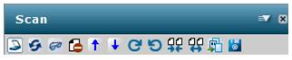

Panel Menu |  |  | Scan options.
 | Start/Pause Scanning |  | Scan files.
 | Refresh Scanner List |  | Refreshing the available scanners accessible to a user's workstation in the Scanner list.
 | View |  | View the document.
 | Delete |  | Delete the selected page(s) or document(s) from the batch.
 | Move Up |  | Move the selected page up in the Document list displayed in the Scan Progress area.
 | Move Down |  | Move the selected page down in the Document list displayed in the Scan Progress area.
 | Rotate Clockwise |  | Rotate the scanned image clockwise 90 degrees.
 | Rotate Counter-  Clockwise |  | Rotate the scanned image counter-clockwise 90 degrees.
 | Combine Pages |  | Combine selected pages into a single, multi-page document.
 | Split Documents |  | Split the selected document into individual pages.
 | Print Barcode |  | Print the DocFinity Barcode Separator Page for use with scan. Opens a new browser window and a print dialog.
 | Save Batch |  | Save the batch of scanned pages to the system.

