DocFinity v10 Basics
Guide to Menus, Workspace and Panels

Table of Contents

Access to Images and Application Functions 3
Groups: 3
Requests for Access to Additional Image Types or Application Functions: 3
Log In and Security for PSU Users 3
DocFinity Web Site: 3
DocFinity Welcome Screen: 4
Welcome screen: 4
DocFinity v10 Menus 4
DocFinity Menu: 4
Preferences: 4
Workspace Menu: 7
Indexing Workspace 7
Scanning Workspace 9
Searching Workspace 10
Panels Menu 12
Batch Panel 13
Index Panel: 14
Help Menu: 14

Access to Images and Application Functions

Groups:
- All PSU users are assigned to Groups in DocFinity Version 10.
- The rights and features assigned to the Group controls the access of the users in the group. Requests for additional access are sent to DocFinity support using the Access Request button on the DocFinity web site.

Requests for Access to Additional Image Types or Application Functions:
- Requests for access are sent to PSU Docfinity Support
- The Access Request form is accessed on the DocFinity web site.
- Click the Access Request button.

Log In and Security for PSU Users

DocFinity Web Site:
Application log in is accessed on Corporate Controller web site. PSU Web Access provides security to the application.

Logging In:
- Web site
- Click Log In.

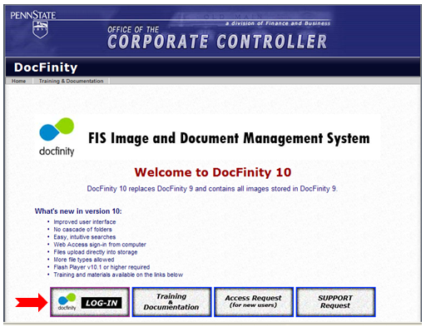

- Enter PSU Web Access credentials.

DocFinity Welcome Screen:
This optional tool was developed to make getting started easy.

Welcome screen:
- Select Workspace to begin working.

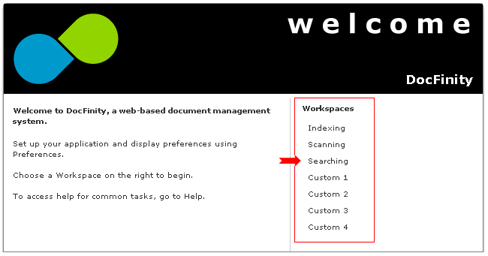

- The custom workspaces can be set up using the instructions on the Help Menu if desired.

DocFinity v10 Menus

DocFinity Menu:
- Preferences can be set for actions and panel displays.
- Logout command can be used or browser tab can be closed to end session.

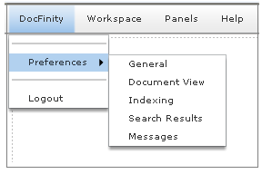

Preferences:
Default settings have been set for all PSU users efficient use of the system. Experienced users may want to experiment with different options.

Preference Tabs:
- General
- Document View
- Indexing (will only be available for users with indexing rights)
- Search Results

General Preferences
Checkbox for Descriptions Text will display descriptors under each title bar for Workspaces and Panels. Descriptors are turned on by default. Uncheck display checkbox to turn off.

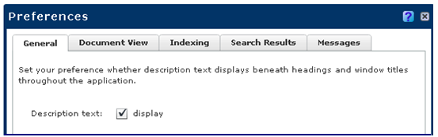

Document View Preferences
Set viewer option for all images. Selection will be the default for displaying selected images.

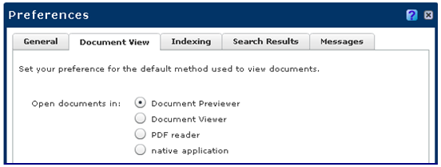

Indexing Preferences
Set preferences for indexing behaviors. By default none are selected.

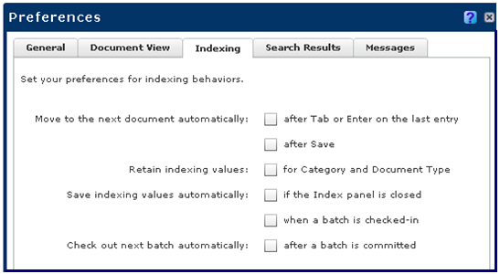

Search Results Preferences
One additional column can be added to the Search Results display. Useful if Pointers and Diary entries are added to images and documents. PSU users will have the feature rights to add pointers when indexing. Displaying the column is turned on by default. Can be turned off by unchecking the checkbox.

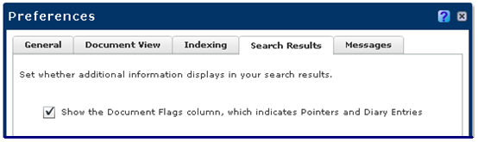

Messages Preferences
The only selection that is related to PSU users is the Indexing option.

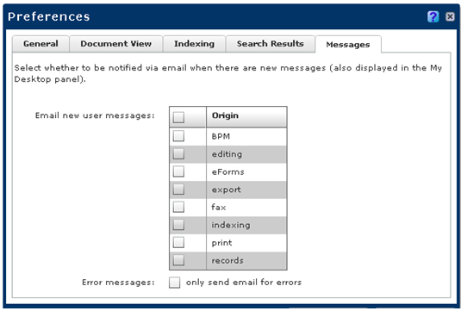

Workspace Menu:
- A Workspace is a set of panels that open by default.
- Users can add or remove panels once workspace is opened.
- Changes to layout can be saved using the "Save as Current" selection.
- "Restore Default Workspaces" will return workspaces to default layout of panels.
- Must have user rights to a workspace to have it included in the Workspace list.
- Custom workspaces can be set up by users. Help Menu has instructions.
- See screen shot below.

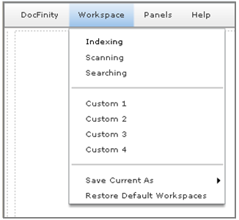

Indexing Workspace:
- Includes panels for: Batches, Document Viewer and Indexing.
- Can resize, move or close each panel.
- Each has drop down menu and button bar.
- See screen shot below.

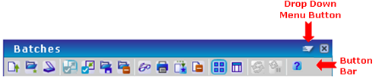

To begin indexing:
- Unindexed batches of scanned or uploaded images and documents are displayed in the Batches panel.
- Batches are selected and the Check Out button used to check out the batch for indexing.
- See screen shot below.

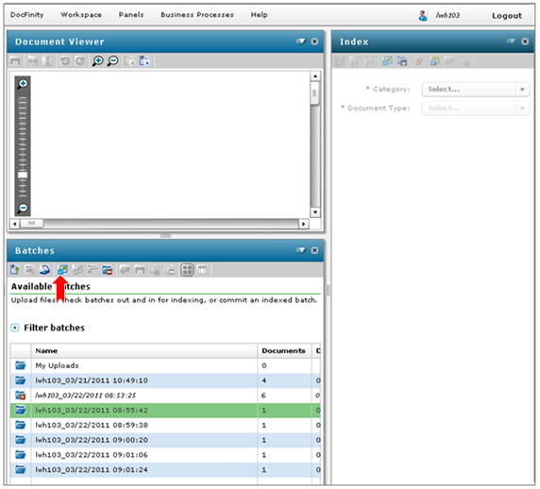

Checked-Out Batches are ready for indexing:
- Batch Panel display changes to display of thumbnails of images in batch. See screen shot below.
- First image in batch will display in Document Viewer where it can be edited if needed.
- Any image in batch can be selected to be opened in Document Viewer.
- Index panel contains metadata fields to complete.
- Required metadata fields have an * to the left of the field name.
- See screen shot below.

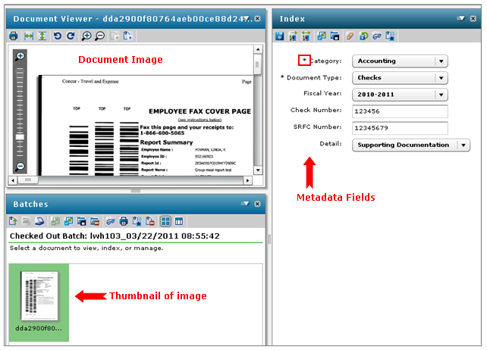

Scanning Workspace
- Includes panel for scanning. See screen shot below.
- Panel has selections for scanning options.
- Scan Configuration section sets up scan. User makes selections.
- Scanning Profile is set up by Administrators. It controls single page or multi-page scanning, which scanner is to be used, etc. New Scan Profiles can be set up when needed. Contact Help Desk.
- Scan Progress displays images as scanned allowing for quick quality check.
- Images can be manipulated if needed with buttons or Panel menu.
- Images are saved into Batches.
- Batch Properties: Access to Batch is given prior to scanning for each group that needs access to the batch for indexing.
- Refer to Scanning Images documentation for more details on the scanning process.
- See screen shot below.

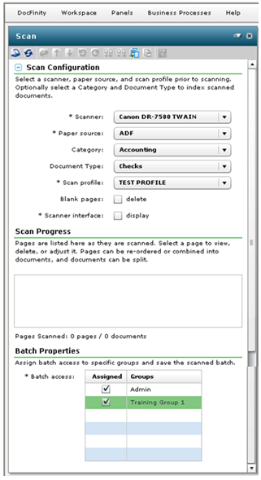

Searching Workspace
- Includes Panels for: Search, Document Viewer and Search Results.
- Can resize, move or close each.
- Each panel has drop down menu and button bar.

Search Panel:
- Search is selected from drop down list of searches. See screen shot below.
- Criteria are selected or entered in available fields to be searched for.
- Custom searches can be created. Contact help desk with requests.

Search Results Panel:
- Documents matching the selected criteria display in the Search Results panel. See screen shot below.
- Documents can be viewed in the Document Viewer, printed, e-mailed, downloaded, annotated or reindexed.

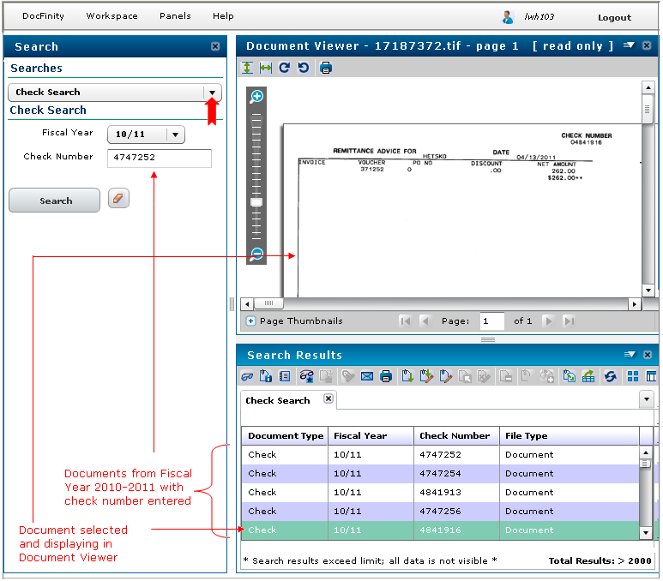

Document Viewer Panel
- Buttons and the drop down menu allow user to control view.
- Images can be e-mailed, printed or copied when the Open as PDF command is used.

Panels Menu
- Select a Panel for specific tasks as needed.
- Some panels contain functions not available to PSU users at this time.

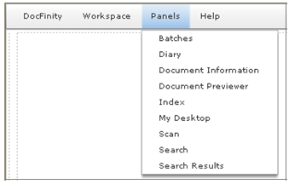

- Each panel has a Button Bar and a Drop Down menu for tasks and displays.

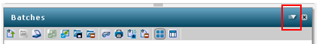

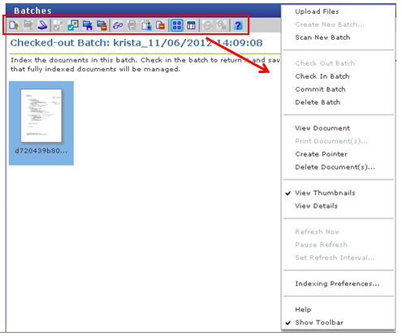

Batch Panel
- Batch panel is used to access batches, search batches and manage batches.
- Documents Upload is done in the Batch panel. All file types are supported for upload.
- Batch panel displays batches of unindexed scanned images and uploaded documents.
- Uploaded documents are placed into My Uploads batch by default.
- Uploaded documents must be indexed just as scanned images are indexed.
- Batches must be checked out by user to begin indexing or to view images.
- Select Batch and click the Check Out button.

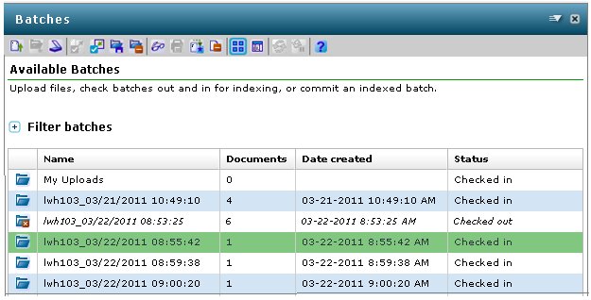

- When a batch is checked out the Batch Panel display changes to thumbnail images for each image or document contained in the batch.

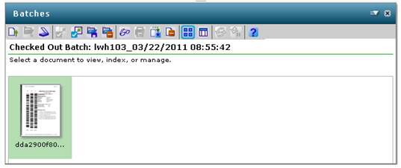

Index Panel:
- Index Panel includes the Metadata that is to be assigned to images and documents.
- Selections are made or information typed for each Metadata field.
- The Metadata is added to the image or document and Saved.
- Metadata selections can be mass assigned and saved.
- When indexing is complete for a batch it must be committed. This completes the indexing process and releases the images and documents into the searchable database.
- Refer to Indexing Images documentation for more details on the indexing process.

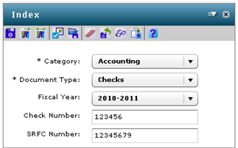

Help Menu:
- Contents contain DocFinity help by topic.
- Hot Keys Reference defines all default hot keys built into version 10.

