ARID/URID/IRID FUNCTIONS DOCUMENTATION

PURPOSE:

The purposes of these functions are to Add (ARID), Inquire (IRID), or Update (URID)
Research Incentive Fund Distribution

ARID FUNCTION

ARID function is used to add new research incentive distribution (RID) information to an existing account (restricted funds only!). For the first fiscal year after implementation (2000/2001), it is permissible to add new RID records to a closed account. After 07/15/2001 this option will be closed, and then this function would only be available to use on active accounts.

Note: if RID record is added to a closed account, make sure that the closed date is correct. There can be a case when there is more then one closed account with the same account number and different closed dates. The right account can be chosen through BFND or BAAC functions.

The screen of ARID function is displayed below (screen 1.1). If the account is not entered in the NEXT ACCT# line, the message ‘ENTER BUDGET AND FUND FOR RECORD RETRIEVAL’ would be displayed.

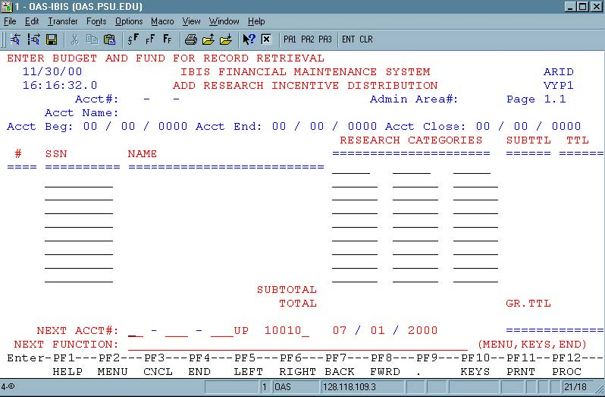
Screen 1.1.

After entering the account # and pressing the ‘ENTER’ key, the cursor is moved to the first category position, and message ‘ENTER INCENTIVE DISTRIBUTION DATA FOR THIS ACCOUNT’ is
displayed. (Screen 1.2).

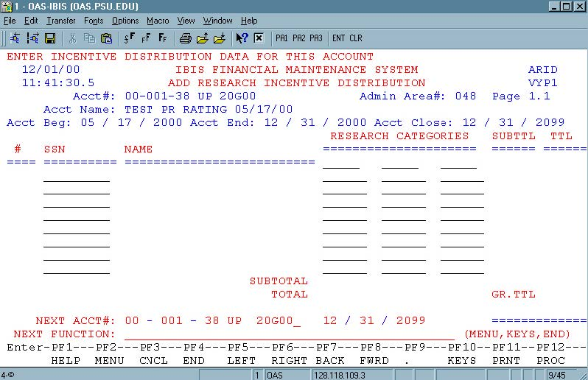
Screen 1.2.

If moving from another function, for example, an account was selected with BFND function and ARID entered in the NEXT FUNCTION line, this account would be used as an input key for ARID, and the screen 1.2 would be displayed.

Pressing the PF1 key on the category field will bring up a list of categories available. (Screen 1.3)

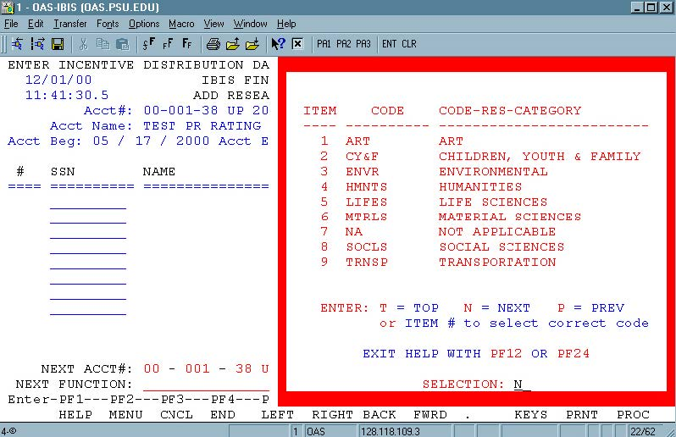
Screen 1.3.

Note: All research categories should be valid, the same category cannot be entered more then once, and the maximum number of categories for one account can be 6 categories.

After all categories are selected or entered on the screen, input SSN(s) of the PI(s) and percent(s) of incentive distribution for this person(s). Note: Only SSN of the University employee can be used for this function; the same SSN cannot be used more then once.

Proceed the same way with the rest of the PIs participating in the project (Screen 1.4). PI(s) can be entered even if his/her incentive distribution for this account is 0%.

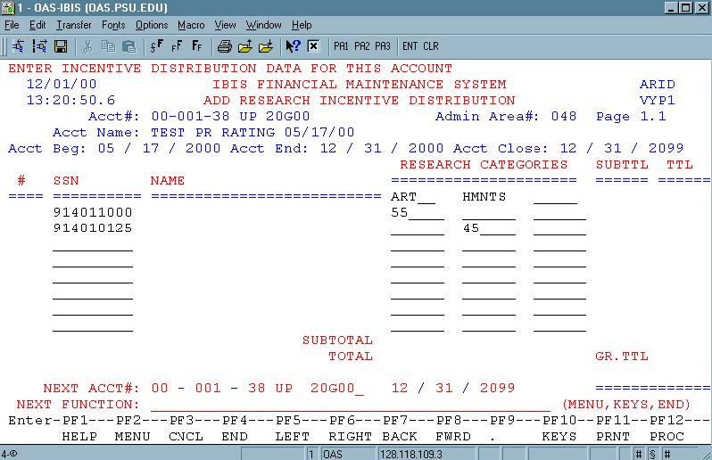
Screen 1.4.

After all information is filled on one screen, press the ‘ENTER’ key. Numbers and names would be inputted automatically and subtotals and totals by category and by SSN will be calculated.

Message “ ‘PF12 TO ADD -- ‘PF3’ TO CANCEL – ‘PF8’ MORE SSN – ‘PF6’ MORE CATEGORIES”
will be displayed at the top of the screen. (Screen 1.5).

Press PF12 key to create a record. If the add should be canceled, press PF3.

PF8 key will bring next page down, PF7 – previous page up. These keys should be used if there are more than 8 PIs participating in the project (there is a maximum of 40 SSNs per account – 5 pages).

PF6 key will display next page to the right, PF5 – previous page to the left. These keys should be used if there are more then 3 categories for this project (maximum 6 categories – 2 pages).

Important note: ALWAYS press ‘ENTER’ key first before paging up/down or left/right. Otherwise information entered on the previous screen will be lost!!!

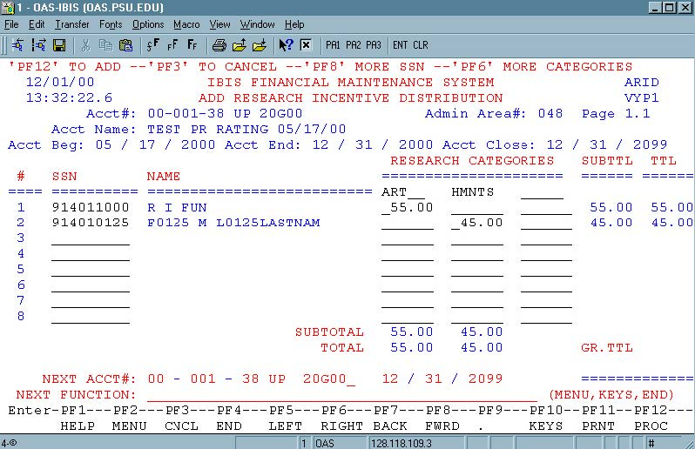
Screen 1.5.

After pressing PF12 key the grand total for this account and the messages ‘RID RECORD WAS CREATED FOR .. (account number) …’ will be displayed. Note: Grand total should always be equal 100%. (Screen 1.6).

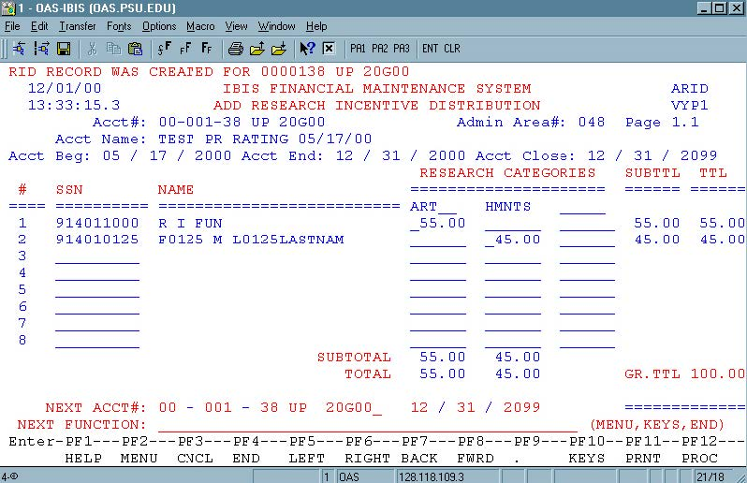
Screen 1.6.

If the add was canceled message ‘RID ADD WAS CANCELED. PRESS ENTER TO CONTINUE’ will be displayed.

If research incentive distribution record already exists for an account, URID (update research incentive distribution) function should be used for changes or IRID (research incentive distribution inquiry) for inquiry.

URID FUNCTION

URID function is used to update existing research incentive distribution record (RID). For the first fiscal year after implementation (2000/2001), it will be permitted to update RID records for a closed account. After 06/30/2001 this option will be closed, and this function would be used only for opened accounts. It is only necessary to update those accounts that were open at some point during the 2000/2001 fiscal year.

The screen of URID function is displayed below (screen 2.1). If the account number is not entered in the NEXT ACCT# line, the message ‘ENTER BUDGET AND FUND FOR RECORD RETRIEVAL’
would be displayed.

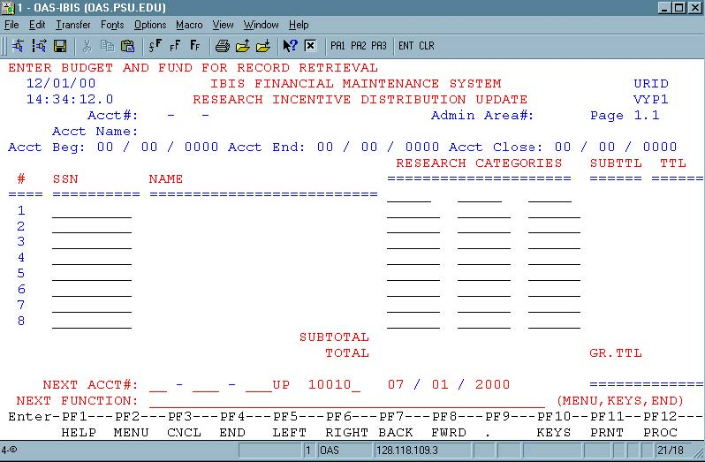
Screen 2.1

After entering account # and pressing ‘ENTER’ key, the research incentive distribution record for this account is displayed and the cursor is moved to the first category position (screen 2.2).

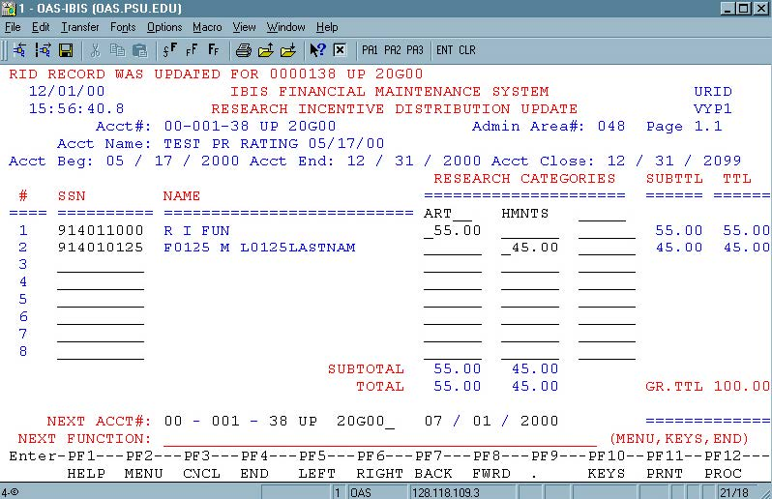
Screen 2.2

If moving from another function, for example an account was selected with BFND function and URID was entered in the NEXT FUNCTION line, this account number would be used as the input key for URID, and the screen 2.2 would be displayed.

SSN(s), category(s), percentage(s) of incentive distribution can be changed, entered or/and deleted as long as all SSN(s) and category(s) are valid and not duplicated, and a grand total of the incentive distribution is equal to 100%.

After changes have been made, press the ‘ENTER’ key. The message ‘CHANGES HAVE BEEN MADE PF3- CANCEL OR PF12-PROCESS’ will be displayed (screen 2.3).

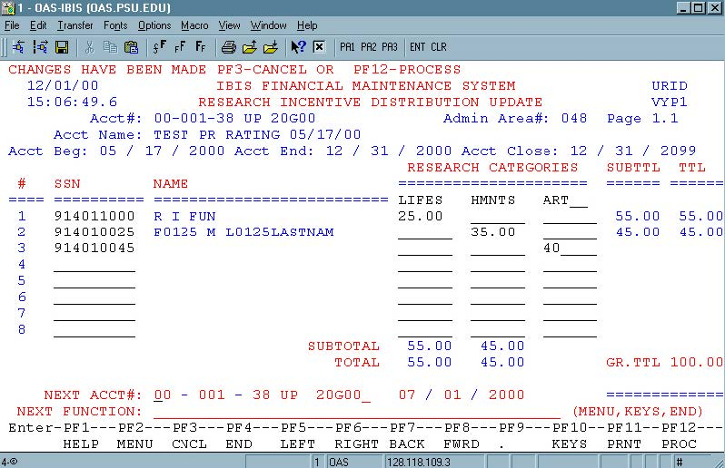
Screen 2.3

To cancel changes press the PF3 key. To update the record press PF12 key. The message ‘RID RECORD WAS UPDATED FOR … account number …’ is displayed. Names would be changed if SSN were changed. Subtotals and totals for all categories and all SSNs and grand total for the account will be recalculated and displayed (screen 2.4).

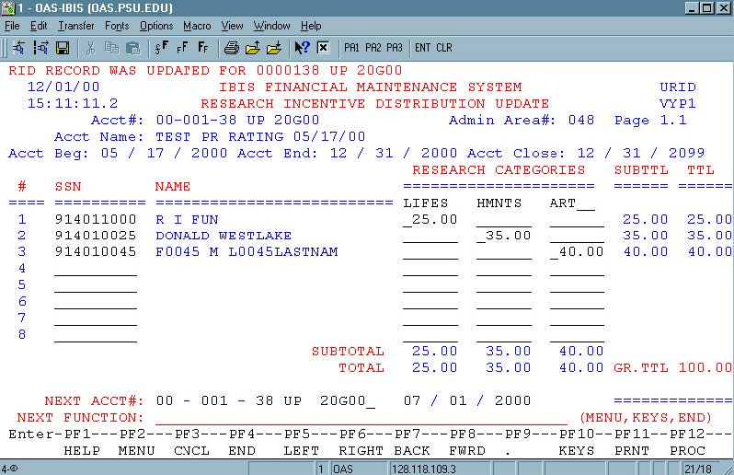
Screen 2.4

PF8 key will bring next page down, PF7 – previous page up. These keys should be used if there are more then 8 PIs participating in the project (maximum 40 SSN – 5 pages).

PF6 key will display next page to the right, PF5 – previous page to the left. These keys should be used if there are more then 3 categories for this project (maximum 6 categories – 2 pages).

Important note: ALWAYS press ‘ENTER’ key first before paging up/down or left/right. Otherwise, information changed on the previous screen will be lost!!!

- IRID FUNCTION

The IRID function is used for inquiry on existing research incentive distribution record (RID).

The screen of the IRID function is displayed below (screen 3.1). If the account number is not entered in the NEXT ACCT# line, the message ‘ENTER BUDGET AND FUND FOR RECORD RETRIEVAL’
will be displayed.

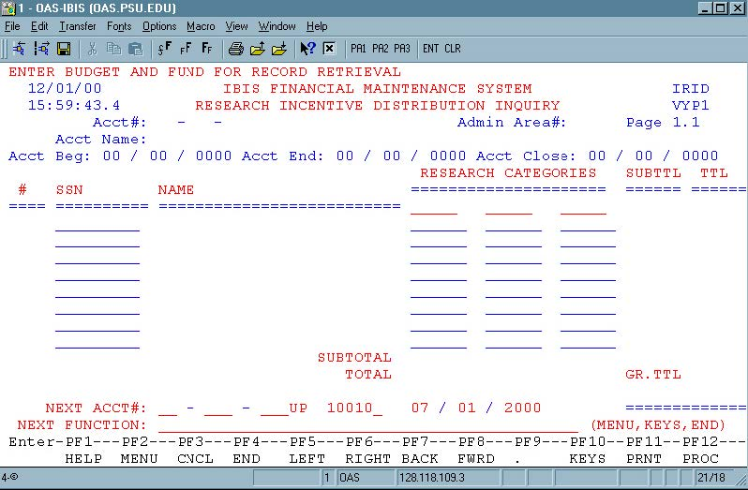
Screen 3.1

After entering the account number, and pressing ‘ENTER’ key, the research incentive distribution record for this account is displayed (screen 3.2).
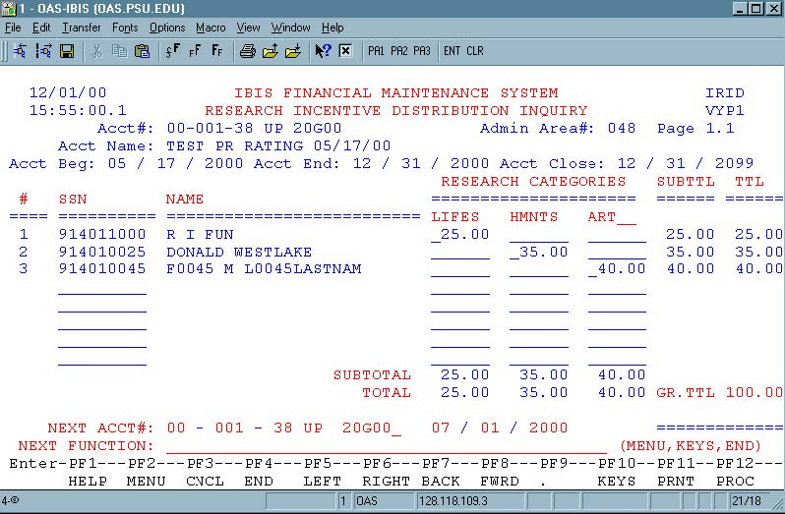

Screen 3.2

If moving from another function, for example, an account was selected with BFND function and IRID was entered in the NEXT FUNCTION line, this account would be used as an input key for IRID, and the screen 3.2 would be displayed.

PF8 key will bring the next page down, PF7 – the previous page up. These keys should be used if there are more then 8 PIs participating in the project (maximum 40 SSN – 5 pages) (Screen 3.3, 3.4)
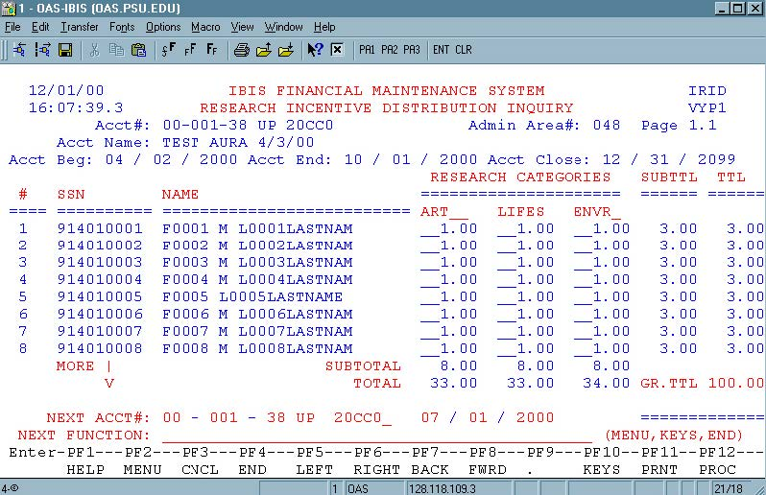

Screen 3.3
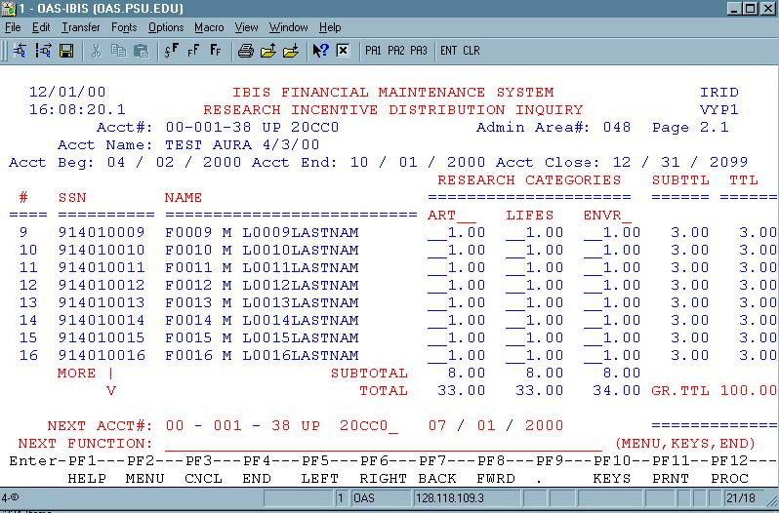
Screen 3.4

PF6 key will display the next page to the right, PF5 – previous page to the left. These keys should be used if there are more then 3 categories for this account (maximum 6 categories – 2 pages) (Screen 3.5, 3.6).

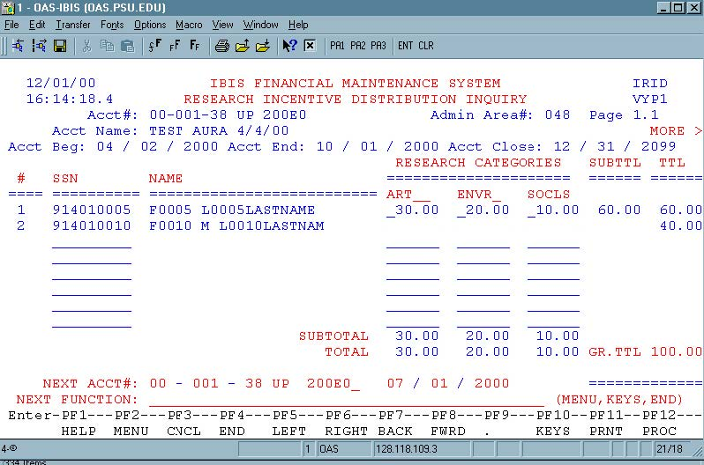
Screen 3.5
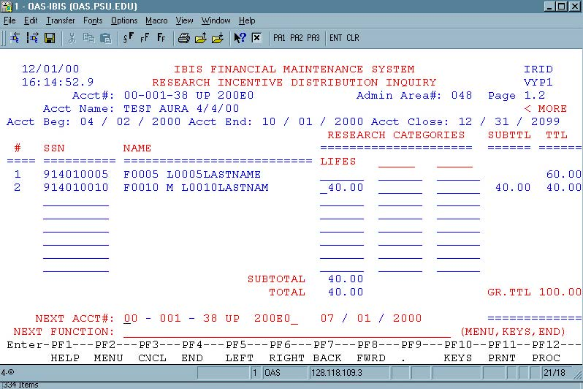

Screen 3.6

NOTE: All accounts and SSN(s) used for this documentation are test data and do not exist in production.

