Searching for Accounting Images/Documents
in DocFinity V10

These are the searches built into DocFinity version 10 that are used for finding Accounting Images in the repository. Each search finds a specific document type(s). Each search is defined below and the link will open the page in this document that contains the steps for completing the search.
Click on document type for more details on searching for the images.
Cash Receipts – p. 6
Use Cash Receipt Search to find a cash receipt and supporting documentation by C9 Number.
Checks – p. 2
Use Check Search to find a check image by the Check Number and/or by Fiscal Year.

SRFC and supporting documents – p. 5
Use Documents Search to find documents by SRFC # (IBIS #).

Journal Vouchers, JV Requests and supporting documentation – p. 3
Use Journal Voucher Search to find Journal Vouchers, JV Requests and supporting documentation by JV number.

General Ledgers – p. 7
Use General Ledger Search to find Ben Franklin Ledgers by Fiscal Year and PSRF Ledgers by Calendar year.

Purchase Order Change Orders – p. 8
Use Purchase Orders Search to find purchase order change orders and related documentation. Sometimes original purchase order image is available with the change orders.

Vouchers - Back up for Checks or Wire Transfers - p. 4
Use Voucher Search to find invoices and vouchers by Voucher number.

Note about printing and e-mailing images:
If it is usual for you to print or e-mail an image when you have located it you will want to make a setting change that will automatically have your images open as a PDF. In the PDF view you will be able to print or e-mail image using the Acrobat commands. To view all images as a PDF follow the steps listed on this link or go to p. 12.

How do I find a check?
- In Search select Check Search.

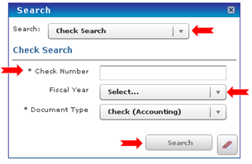

- Enter a Check Number.
- Select Fiscal Year from drop down or leave blank.
- Click Search.
- Results from search will display in the Search Results Panel.
- The Search Results for checks will display the fields shown below.

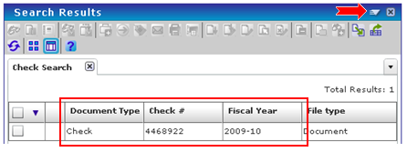

- Double click entry to view in Document Previewer. To print or e-mail image use the drop down Menu and select Open as PDF. Use the PDF commands to print, e-mail or save a copy.

Back to Top
How do I find a journal voucher?
- In Search select Journal Voucher Search.

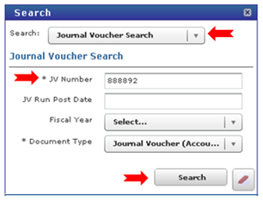

- Enter JV Number. It is a required field.
- Enter JV Run Post Date if known. (Note: Could be IBIS postdate or eDDS postdate. Click here for help finding these dates.) Images are indexed in DocFinity using the IBIS postdate.
- Select Fiscal Year or leave blank.
- Click Search.
- Results from search will display in the Search Results Panel.
- The Search Results for journal vouchers will display the fields shown below.

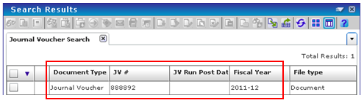

- Double click entry to view in Document Previewer. To print or e-mail image use the drop down Menu and select Open as PDF. Use the PDF commands to print, e-mail or save a copy.

Back to Top
How do I find a voucher or invoice?
- In Search select Voucher Search.

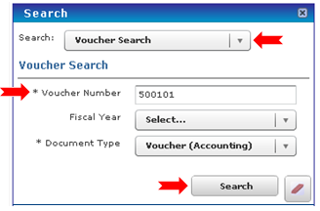

- Enter Voucher Number. It is required.
- Select Fiscal Year from drop down list or leave blank.
- Click Search.
- Results from search will display in the Search Results Panel.
- The Search Results for vouchers will display the fields shown below.

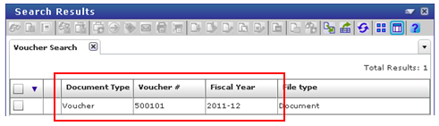

- Double click entry to view in Document Previewer. To print or e-mail image use the drop down Menu and select Open as PDF. Use the PDF commands to print, e-mail or save a copy.

Back to Top
How do I find a SRFC and its supporting documentation?
The Document Search based on IBIS Number is used to find:
- Requests for Reimbursement Group Meal Forms,
- Group Meal / Group meeting Support Forms,
- Catering Invoices and the supporting documentation,
- Travel Receipts,
- Cash Receipts,
- Receipts for Petty Cash Expended,
- ERS Worksheets and supporting documentation,
- Time Sheets for Research Mentors / Stipends,
- Visitor Information Sheet for Income and Travel,
- Key Deposit Refund Authorization Forms,
- Direct Deposit Receipts

- In Search select Document Search.

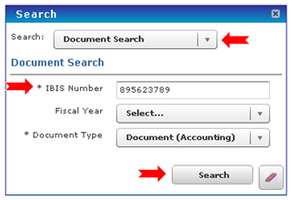

- Enter IBIS Document Number (SRFC#). It is required.
- Select Fiscal Year or leave blank.
- Click Search.
- Results from search will display in the Search Results Panel.
- The Search Results for document search will display the fields shown below.

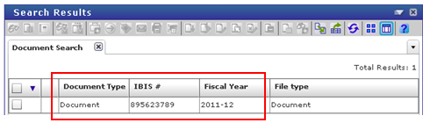

- Double click entry to view in Document Previewer. To print or e-mail image use the drop down Menu and select Open as PDF. Use the PDF commands to print, e-mail or save a copy.
- Because no other metadata could be assigned to the legacy images, each image in the search result will need to be displayed to find the exact image needed relating to the SCRF Number.

Back to Top

How do I find a cash receipt?
- In Search select Cash Receipt Search.

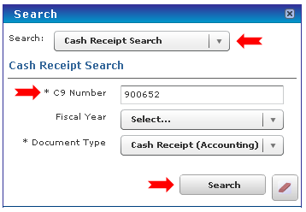

- Enter the C9 Number. It is required.
- Select Fiscal Year or leave blank.
- Click Search.
- Results from search will display in the Search Results Panel.
- The Search Results for cash receipt will display the fields shown below.

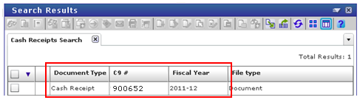

- Double click entry to view in Document Previewer. To print or e-mail image use the drop down Menu and select Open as PDF. Use the PDF commands to print, e-mail or save a copy.

Back to Top
How do I find a General Ledger for Ben Franklin or PSRF?
- In Search select General Ledger Search.
- For Ben Franklin Ledgers select a Fiscal Year from the drop down list.
- For a PSRF Ledgers select a Calendar Year from the drop down list.

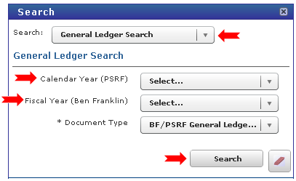

- Click Search.
- Results from search will display in the Search Results Panel.
- The Search Results for general ledgers will display the fields shown below.
- Each page of the Ledger will be a separate image.
- This Ben Franklin Ledger contains 21 pages. Each is a separate image in the set of 21 documents returned in the search. See below.

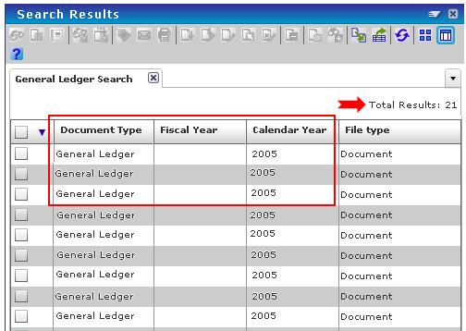

- Double click entry to view in Document Previewer. To print or e-mail image use the drop down Menu and select Open as PDF. Use the PDF commands to print, e-mail or save a copy.

Back to Top
How do I find a Change Order for a Purchase Order?
- In Search select Purchase Order Search.

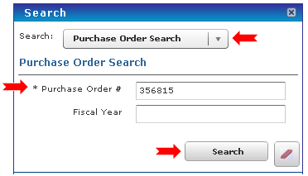

- Enter the Purchase Order Number. It is required.
- Select Fiscal Year only if you want to restrict the documents you see to a specific year. Not selecting a year will allow all the change orders for a purchase order to be found. There can be any number of change orders for a Purchase Order and often they will be in different years.
- Click Search.
- Results from search will display in the Search Results Panel.
- The Search Results for purchase Orders will display the fields shown below.

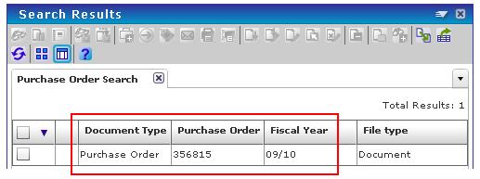

- Double click entry to view in Document Previewer. To print or e-mail image use the drop down Menu and select Open as PDF. Use the PDF commands to print, e-mail or save a copy.

Back to Top

Journal Voucher Run Post Dates

To locate IBIS post date:

- In IBIS use ICAG function. See below.

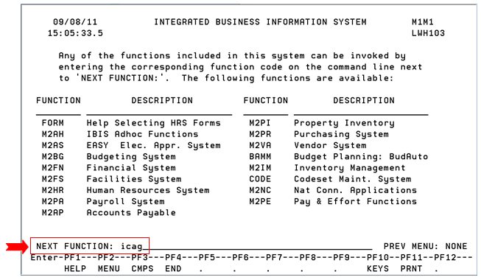

- Enter Account Number and press Enter. See below.

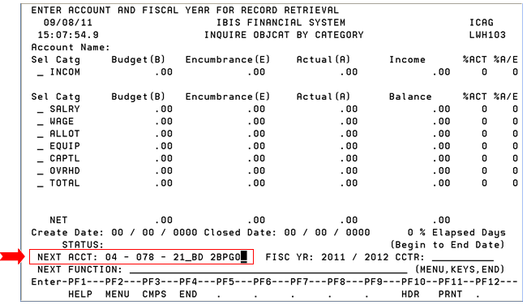

- In front of Allot type an “a” for actuals. Press Enter. See below.

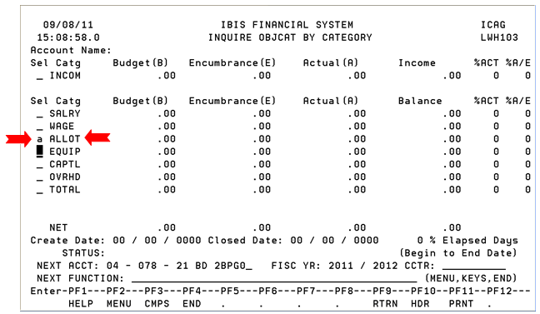

- Look for entry. Use PF8 to page forward in the list of entries if needed. Use PF9 to return to prior screen. See below.

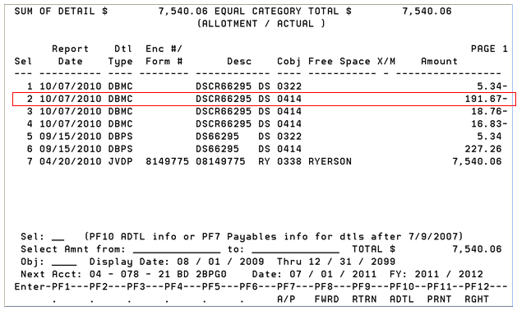

- Type the number of your entry in the Sel: field. Press Enter. See below.

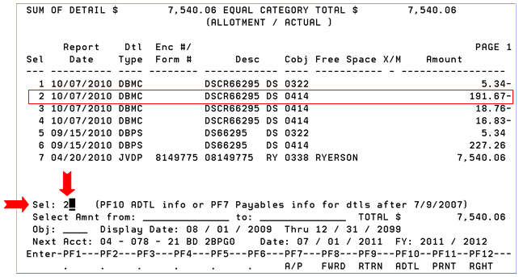

- Check for Posted Date. Note the Cent Ref # is the JV Number. See below.

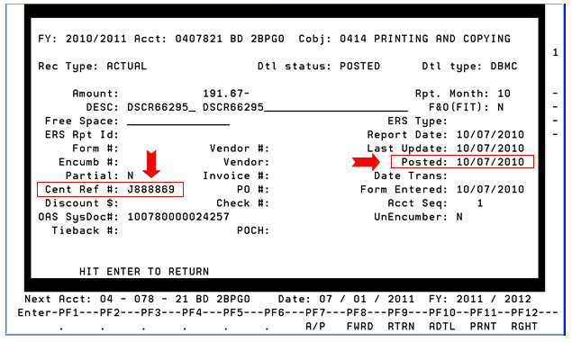

Note: In DocFinity images are indexed with the Posted Date in IBIS as the JV Post Date.

- Press Enter to close window.
- Press PF9 to return to ICAG screen where a new account can be entered or press PF4 to quit.

Note: Usually the eDDS post date will match the JV Post Date, but it could be 1 day after. Use the JV Post Date for searching for images. Images are indexed with that date.

Back to Journal Voucher Search steps.

Setting Preferences to Open Images in PDF Reader

To change your viewing options follow these steps:

- Log in to DocFinity Version 10.
- Open the Searching Workspace.
- On the top Menu bar select DocFinity.
- Slide down to Preferences.
- Slide over and select Document View.
- Select the radio button for “PFD Reader”.
- Click Save.

When you double click an image in the Search Results screen it will open as a PDF.

Does your PDF image open in a new browser tab or in a new browser window?
To change the default setting in your browser follow these steps:

Internet Explorer Steps | Firefox Steps
1. On Tools menu select Internet Options | 1. On Tools menu select Options
2. On General Tab, find Tabs section | 2. On Tabs tab, look for “Open new windows in a new tab instead”.
3. Click Settings
4. In item “Open link from other programs  in:” choose radio button for your preference. (new window or new tab) | 3. Select checkbox to have images open in new tabs.
 | 4. Unselect the checkbox to have images open in new windows.

Back to Top

